

**Business Requirement Document**

**OLSS – CR Asset Selling COP – Phase 3**

**PT. Berlian Sistem Informasi**

**Version Control**

|  |  |  |  |
| --- | --- | --- | --- |
| Author | Version | Date | Description |
| Rayang Amiriyanti | V_1.0 | 29 December 2020 | First Version |
|  |  |  |  |
|  |  |  |  |
|  |  |  |  |
|  |  |  |  |
|  |  |  |  |

1. **Document Reviewers**

|  |  |  |
| --- | --- | --- |
| Role | Organization | Name |
| Division head ISM | PT. Berlian Sistem Informasi | Valentinus A. Bay |
| Unit head | PT. Berlian Sistem Informasi | Devilosa I. Kamal |
| Service manager | PT. Berlian Sistem Informasi | Fajar S. Putra |
| Change manager | PT. Berlian Sistem Informasi | Cristin P. Sari Kaunang |
| ITD Operation Head | PT. Dipo Star Finance | Ahmad Fikri |
| Superior | PT. Dipo Star Finance | Irma Verdian |
| Requestor | PT. Dipo Star Finance | Antonius Fedrik |

Contents

1. Introduction and High-Level Requirement 4

1.1. Purpose of Document 4

1.2. High Level Requirement 4

1.3. Need and Benefits of Requirement 4

1.4. Reference/Source Document 4

2. Requirement Description 4

2.1. In Scope 4

2.2. Out Scope 4

2.3. Current Functionality 5

2.4. Proposed Functionality 7

2.5. Workflow Requirement 18

3. Risks and Mitigation 19

4. Glossary 19

5. Annexures 19

# Introduction and High-Level Requirement

## Purpose of Document

The main purpose of this document is to understand and record the requirement from PT. Dipo Star Finance. This document will serve as the main reference document for Profit Analysis in Manage Memo and Manage Report. This document will be sent along with RFC document.

## High Level Requirement

Currently, OLSS only provide the expense and income calculation for SKD budget for all total unit and Actual. However, user also need to see the calculation for SKD budget for unit sold. Hence, in this phase the defined changes will overall modify the screen of detail profit analysis in module of manage memo & manage report.

OLSS will provide new calculation of expense and income for SKD budget for unit sold. There will be updates as well in the report of profit analysis where data of plat number will be provided as well next to the total unit. The further detail about these requirements will be described in Business Requirement Document (BRD).

## Need and Benefits of Requirement

With these changes, System can provide more accurate calculations of profit budget for unit sold.

## Reference/Source Document

CR Number IT-CFR-200420-855 Asset Selling COP #46850.

# Requirement Description

## In Scope

Scope of this CR is limited to:

1. Profit Analysis of SKD Budget All total unit and unit sold.
2. Print report of Profit Analysis
3. Print report of Lampiran Hasil Investasi
4. Profit Budget in Manage Memo & Manage Report

## Out Scope

1. Profit Analysis of Actual
2. Expense and Income calculation for Actual
3. Selling Price in Profit Analysis screen
4. Lampiran Profit Analysis

## Current Functionality

**Profit Analysis**

Currently, OLSS only provide the calculation of expense and income for SKD budget for all total unit and Actual. Total unit in profit analysis is data of all total unit based on SKD.

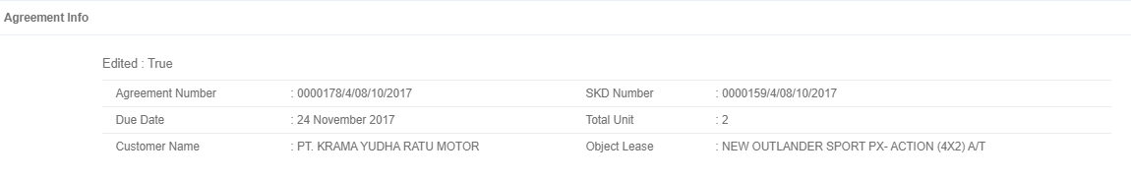

**All Total unit based on SKD**

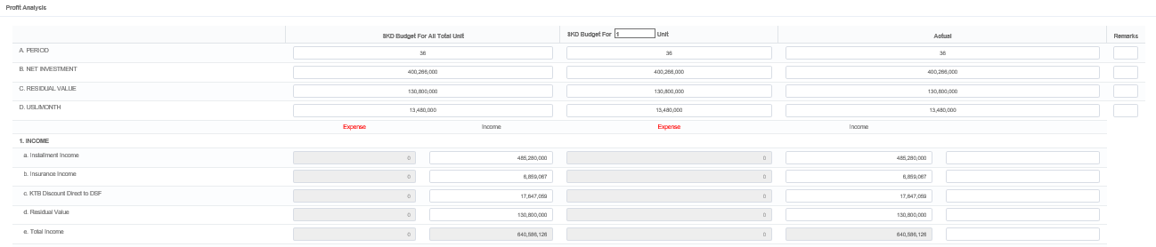

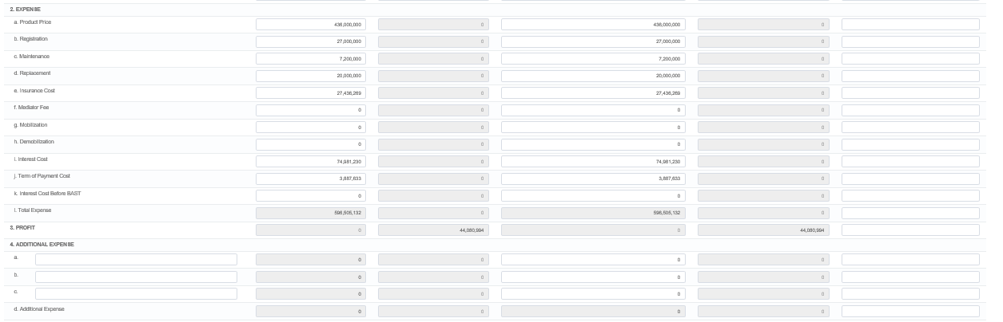

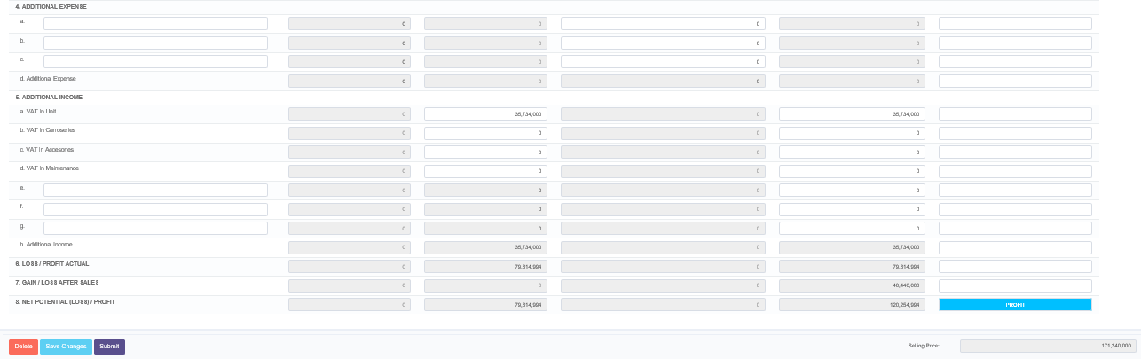

**A**

**B**

**Notes:**

A - the calculation of expense and income for SKD budget for All Total Unit.  
B - the calculation of expense and income for Actual.

**Print Report of Profit Analysis**

There are only data expense and income for SKD budget for all total unit and Actual.

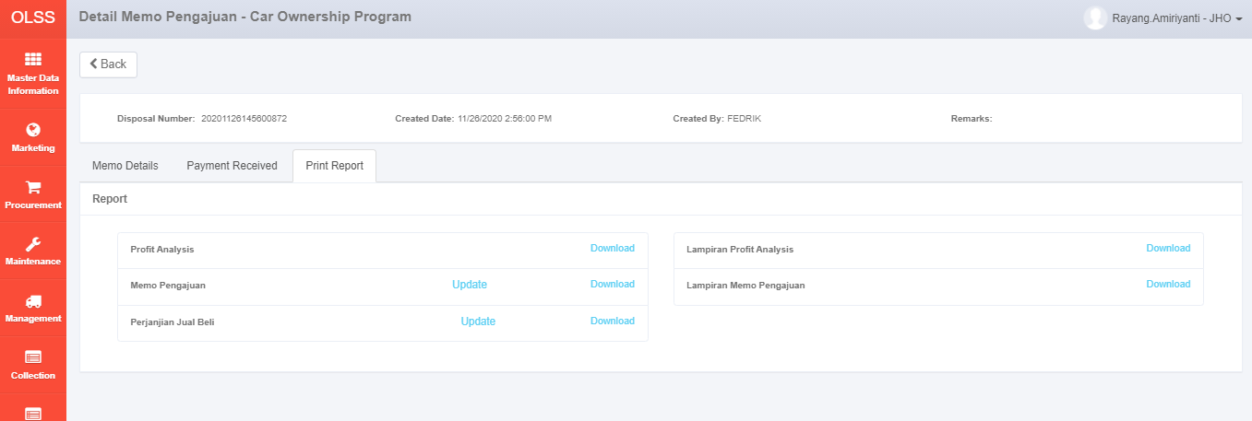

**Only menu to download the report and no menu for updating approval names in print report profit analysis.**

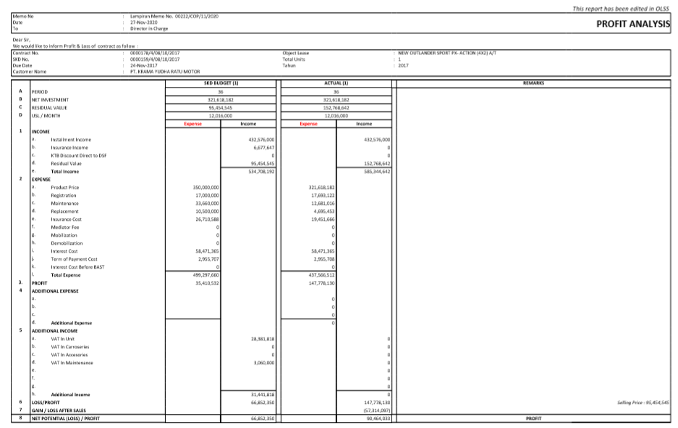

**Only data of Total Unit**

**B**

**A**



**Notes:**

A - the calculation of expense and income for SKD budget for All Total Unit.  
B - the calculation of expense and income for Actual.



## Proposed Functionality

The defined changes of Profit analysis will be applied in Manage Memo & Manage Report for all type of memo (Auction, COP, & Direct Selling). Then, the updated changes can be found in the print report as well for Profit Analysis and Lampiran Hasil Investasi.

1. **Profit Analysis in Manage Memo & Manage Report**

**Business Requirement:**

* User want to be provided new calculation of expanse and income for SKD budget for unit sold. Based on user request, Expanse and Income in SKD budget for unit sold will be generated from data of SKD Budget for all total unit then data will be calculated pro rate (by unit quantity). Besides the data is provided based on pro rate calculation first but user still can modify each input as well because the real data that user receive is not the same with data in OLSS.

**Before:**



**All Total unit based on SKD**







**B**

**A**

Current Functionality:   
System only provide the calculation of expense and income for *SKD budget for all total unit* **(A)** and the calculation of expense and income for *Actual* **(B)***.*

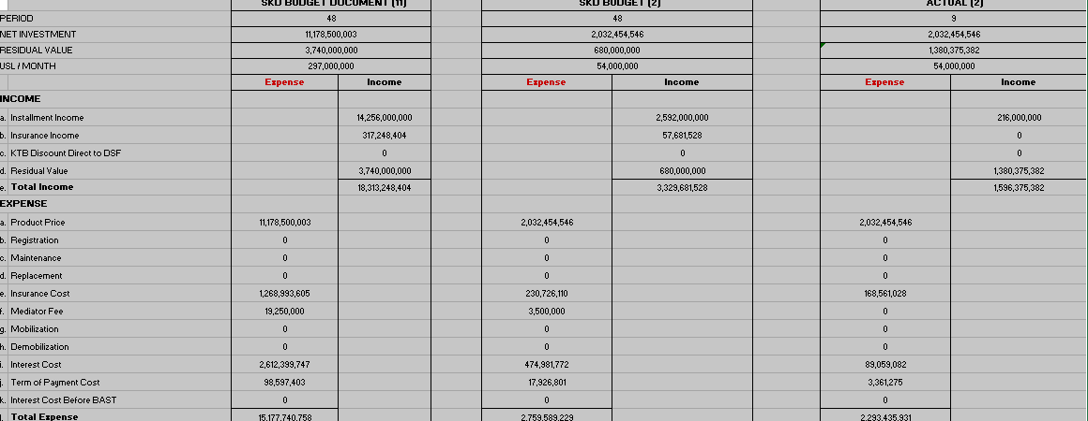**After:**

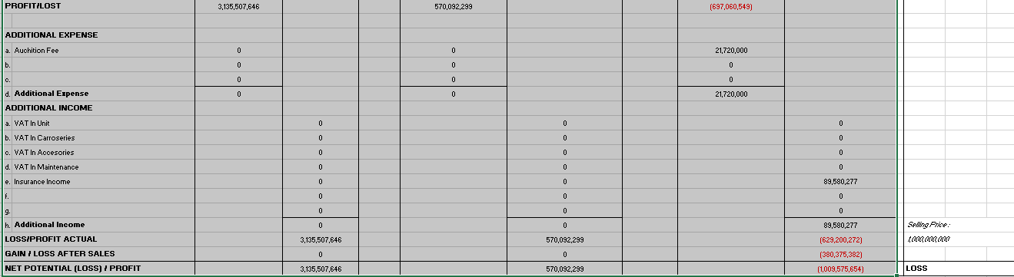

Calculation Expense & Income for ***Actual***

New Calculation Expense & Income for ***SKD Budget Unit Sold***

Calculation Expense & Income for ***SKD Budget All unit***

Proposed Functionality:

* Input Parameters in column of expense & income for SKD Budget for unit sold:

|  |  |  |  |
| --- | --- | --- | --- |
| **Field Name** | **Option to Edit** | **Column Category** | **Description** |
| Installment Income | Yes | Income | USL/Month x Period from SKD Budget for unit sold. |
| Insurance Income | Yes | Income | Calculated pro rate (by unit quantity) based on insurance income for SKD Budget all total unit and quantity of units sold. |
| KTB Discount Direct to DSF | Yes | Income | Calculated pro rate (by unit quantity) based on KTB Discount Direct to DSF for SKD Budget all total unit and unit quantity sold. |
| Residual Value | Yes | Income | Calculated pro rate (by unit quantity) based on Residual Value for SKD Budget all total unit and quantity of units sold. |
| Total Income | No | Income | Sum of Installment income, Insurance income, KTB Discount Direct to DSF, and Residual Value. |
| Product Price | Yes | Expense | Calculated pro rate (by unit quantity) based on Product Price for SKD Budget all total unit and quantity of units sold. |
| Registration | Yes | Expense | Calculated pro rate (by unit quantity) based on Registration for SKD Budget all total unit and quantity of units sold. |
| Maintenance | Yes | Expense | Calculated pro rate (by unit quantity) based on Maintenance for SKD Budget all total unit and quantity of units sold. |
| Replacement | Yes | Expense | Calculated pro rate (by unit quantity) based on Replacement for SKD Budget all total unit and quantity of units sold. |
| Insurance Cost | Yes | Expense | Calculated pro rate (by unit quantity) based on Insurance Cost for SKD Budget all total unit and quantity of units sold. |
| Mediator Fee | Yes | Expense | Calculated pro rate (by unit quantity) based on Mediator Fee for SKD Budget all total unit and quantity of units sold. |
| Mobilization | Yes | Expense | Calculated pro rate (by unit quantity) based on Mobilization for SKD Budget all total unit and quantity of units sold. |
| Demobilization | Yes | Expense | Calculated pro rate (by unit quantity) based on Demobilization for SKD Budget all total unit and quantity of units sold. |
| Interest Cost | Yes | Expense | Calculated pro rate (by unit quantity) based on Interest Cost for SKD Budget all total unit and quantity of units sold. |
| Term of Payment Cost | Yes | Expense | Calculated pro rate (by unit quantity) based on Term of Payment Cost for SKD Budget all total unit and quantity of units sold. |
| Interest Cost Before BAST | Yes | Expense | Calculated pro rate (by unit quantity) based on Interest Cost Before BAST for SKD Budget all total unit and quantity of units sold. |
| Total Expense | No | Expense | Sum of Product Price, Registration, Maintenance, Replacement, Insurance Cost, Mediator Fee, Mobilization, Demobilization, Interest Cost, Term of Payment Cost, and Interest Cost before BAST. |
| Profit/Loss | No | Expense | Total Income – Total Expense |
| Additional Expense 1 | Yes | Expense | Calculated pro rate (by unit quantity) based on Additional Expense 1 for SKD Budget all total unit and quantity of units sold. |
| Additional Expense 2 | Yes | Expense | Calculated pro rate (by unit quantity) based on Additional Expense 2 for SKD Budget all total unit and quantity unit sold. |
| Additional Expense 3 | Yes | Expense | Calculated pro rate (by unit quantity) based on Additional Expense 3 for SKD Budget all total unit and quantity of units sold. |
| Additional Expense | No | Expense | Sum of all additional expense a, b, & c. |
| Additional Income - VAT in Unit | Yes | Income | Calculated pro rate (by unit quantity) based on Additional Income - VAT in Unit for SKD Budget all total unit and quantity of units sold. |
| Additional Income - VAT in Carroseries | Yes | Income | Calculated pro rate (by unit quantity) based on Additional Income - VAT in Carroseries for SKD Budget all total unit and quantity of units sold. |
| Additional Income - VAT in Accessories | Yes | Income | Calculated pro rate (by unit quantity) based on Additional Income - VAT in Accessories for SKD Budget all total unit and quantity of units sold. |
| Additional Income - VAT in Maintenance | Yes | Income | Calculated pro rate (by unit quantity) based on Additional Income - VAT in Maintenance for SKD Budget all total unit and quantity of units sold. |
| Field of e,f,g in Additional Income | Yes | Income | Free input from user to add additional data of income |
| Additional Income | No | Income | Sum of VAT in Unit, VAT in Carroseries, VAT in Accessories, VAT in Maintenance, new additional income (e-g) if user input these field. |
| Loss/Profit Actual | No | Income | Profit/Loss – Total Additional Expense – Total Additional Income. |
| Gain/Loss after sales | No | Income | Gain/Loss after sales always 0. |
| Net Potential (Loss) / Profit | No | Income | Loss/Profit Actual – Gain/Loss After sales |

* Rules Validation for all input fields:

1. Input number can’t be negative value.   
2. Data in input field can be copied by user.

3. All data type in expense & income is Integer.

|  |  |  |
| --- | --- | --- |
| **Before Rounding** | **After Rounding** | **Remarks** |
| 2.490.453,4 | 2.490.453 | < 5 will be rounded down |
| 2.490.453,5 | 2.490.454 | = 5 will be rounded up |
| 2.490.453,6 | 2.490.454 | > 5 will be rounded up |

* The Rounding will use the standard rounding which has been applied in OLSS.

* Total unit in detail profit analysis will show the total number of unit sold and plat number will be provided as well.

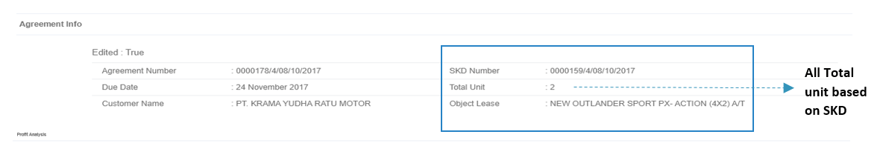**Before:**Current Functionality:  
Total unit is showing the data of total unit based on SKD. And detail about plat number is not provided in the screen.

**After:**

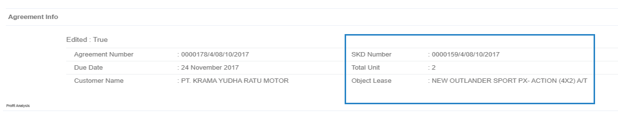

**1 (E8572BW)**

**Total unit will be displayed based on total unit sold with plat number**

Propose Functionality:  
Total unit will show the data of total unit sold based on data asset in memo. And detail about plat number will be provided in the screen as well.

* Profit budget in manage memo & manage report will display the data of net potential (loss)/profit in SKD budget for unit sold.

**Before:**

Screen of Detail Memo Pengajuan:

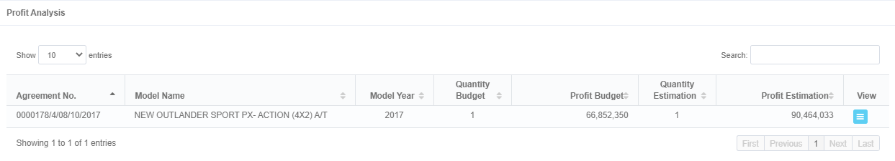

**This data is taken from Net Potential (Loss)/Profit in SKD Budget for all total unit**

Screen of Detail Profit Analysis:

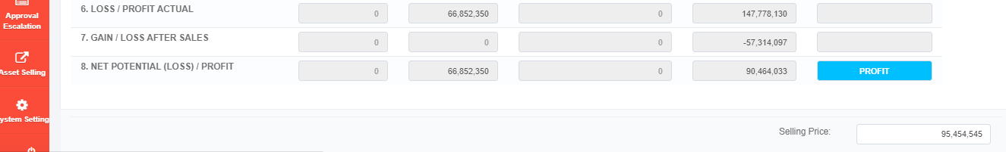

Current Functionality:

Profit budget in manage memo and manage report is showing the calculation of profit/loss for data SKD budget for all total unit.

**After:**

Screen of Detail Memo Pengajuan:



**This data is taken from Net Potential (Loss)/Profit in SKD Budget for unit sold**

**570,092,299**

Screen of Detail Profit Analysis:



Propose Functionality:

Profit budget in manage memo and manage report will show the calculation of profit/loss for data SKD budget for unit sold.



1. **Print Report of Profit Analysis & Lampiran Hasil Investasi**

**Business Requirement:**

* User want data of expense and income in SKD Budget for unit sold from Detail Profit Analysis will be displayed in the report of profit analysis and lampiran hasil investasi.

**Before:**

**This data is shown in Report of Profit Analysis & Lampiran Hasil Investasi.**

Screen of Detail Profit Analysis:



Current Functionality:

Data of expense and income in SKD Budget for all total unit and also some data in SKD budget for unit sold (period, net investment, residual value and USL month) are displayed in report of Profit Analysis and Lampiran Hasil Investasi.

**After:**

**This data will be shown in Report of Profit Analysis & Lampiran Hasil Investasi.**

Screen of Detail Profit Analysis:





Sample of Print Report Profit Analysis:

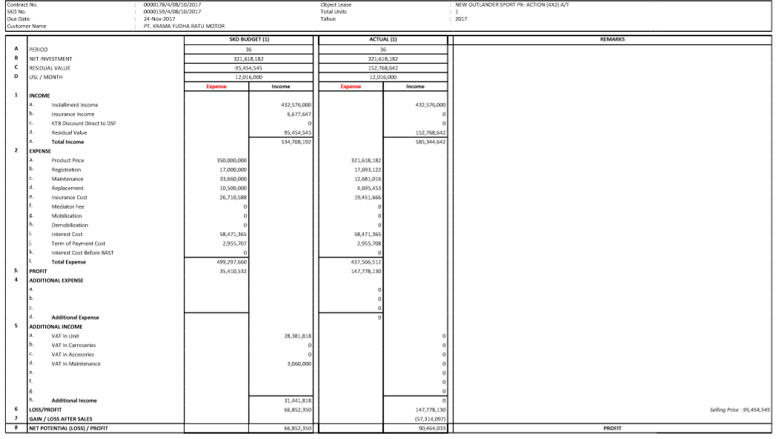

Propose Functionality:

All data in SKD Budget for unit sold (Period, Net Investment, Residual Value, and USL Month and data of expense and income) will be displayed in report of Profit Analysis and Lampiran Hasil Investasi.

* Plat number unit sold is provided at the top screen next to data of total unit based on data in Detail Profit Analysis.

**Before:**

Sample of Print Report Profit Analysis:



Current Functionality:

No plat number is showing in the total unit from the current sample of print report of profit analysis and lampiran hasil investasi.

**After:**

Sample of Print Report Profit Analysis:



**1 (E8572BW)**

Propose Functionality:

Plat number of total unit sold will be showed in print report of profit analysis and lampiran hasil investasi.

* The approval name will be updated based on user requirement and new screen in print report profit analysis and lampiran hasil investasi will be added for user to update some names in the report.

**Before:**

Menu Print Report in Profit Analysis:



**No menu to update the approval names in report.**

Sample of list approval names in Print Profit Analysis and Lampiran Hasil Investasi:



Current Functionality:

No menu for user to update data of approval names which will be appeared in print report of profit analysis.

**After:**

Menu Print Report in Profit Analysis:





**New menu to update the approval names in report will be provided.**

Menu Update in Report Profit Analysis:

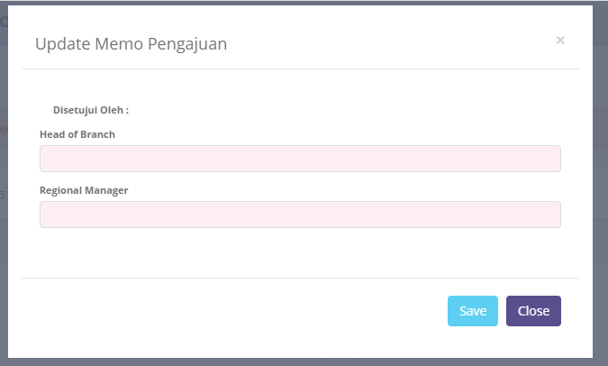

Update Profit Analysis

**Approved by:**

Bing Wan

Eddy Johan

Approval names in report of profit analysis and lampiran hasil investasi:



Propose Functionality:

* There will be new menu for user to update data of approval names which will be appeared in print report of profit analysis. Below is the detail info for the input fields in Update – Print Report Profit Analysis:

|  |  |  |  |
| --- | --- | --- | --- |
| **Input Parameters** | **Mandatory/ Optional** | **Data Type** | **Description** |
| Head of Branch | Mandatory | Alphabetical | * The text will be input in Head of Branch – Approved By. * Default text: Bing Wan. |
| Regional Manager | Mandatory | Alphabetical | * The text will be input in Regional Manager – Approved By. * Default text: Eddy Johan. |

* Approval names in print report profit analysis and lampiran hasil investasi will be updated as based on user requirement.
* Prepare by:

1. (Creator Memo) -> Updated based on the user who create the memo
2. Pathul W.
3. Herni H.

* Di Catat Oleh:

1. Catur A.
2. Yuniar S

* Acknowledge By:

1. Irma Verdian

* Approved By:

1. (Head of Branch) -> the text will be appeared as based on user input from Update screen field of Head of Branch.
2. (Regional Manager) -> the text will be appeared as based on user input from Update screen field of Regional Manager.
3. Suwardi G.
4. Andi Suhono

* However, if user click **Download** without input name in Update screen, then OLSS will show notification warning for user to update the required field.



**Failed!** Please Fill Screen Update Profit Analysis in Print Report – Update Button

## Workflow Requirement

**Profit Analysis & Lampiran Hasil Investasi**

There is one flow that will be added in Profit Analysis & Lampiran Hasil Investasi.

**Before:**

User click **Download** in *Print Profit Analysis* and *Lampiran Hasil Investasi* to directly get the report.

**After:**

User click **Download** in *Print Profit Analysis* and *Lampiran Hasil Investasi* to get the report.

User input data Head of Branch and Regional Manager then click save

User click **Update** in *Print Profit Analysis* and *Lampiran Hasil Investasi*

# 3. Risks and Mitigation

The possibility of the incorrect calculation in SKD Budget for all Total Unit and Actual from Edit Profit Analysis.

**Mitigation:**

Conduct several testing processes to make sure these risks will not occur when we applied the changes.

# 4. Glossary

1. DSF – PT. Dipo Star Finance
2. BSI – PT. Berlian Sistem Informasi

# 5. Annexures

|  |  |  |
| --- | --- | --- |
| **No** | **Document Name** | **Attachment/Path** |
| **1** | **RFC CR Asset Selling COP Phase 3** |  |